Daylilies (hemerocallis)
They grow best in full sun. The plants will grow in partial sun, but will not bloom as well.

 | 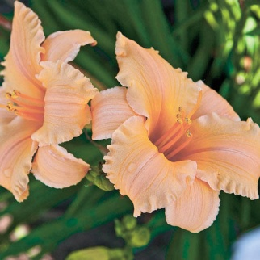 |  |  | Apricot Sparkles  18”tall  4”Apricot, trumpet-shaped flowers  Takes part shade  Fragrant |  | 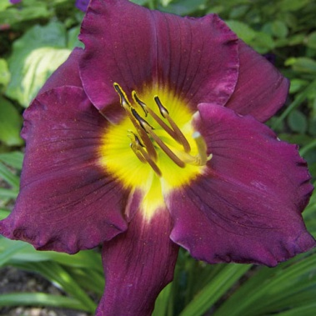 | Bela Lugosi  3’tall, 5” showy, dark purple flowers w lime green throat  Blooms mid-late summer
 | 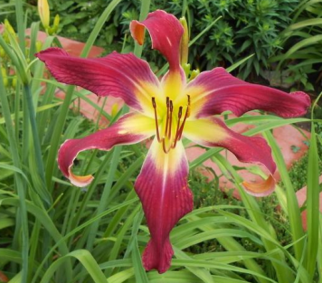 |  |  | Brooklyn Twist $10  2’tall, 9”flowers  Spectaular, red-purple flowers w recurved petals. |  | 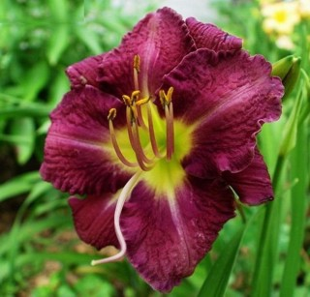 | Chicago Royal Robe  24”tall, 4.5” flowers  Dark wine flowers with chartreuse throat
 | 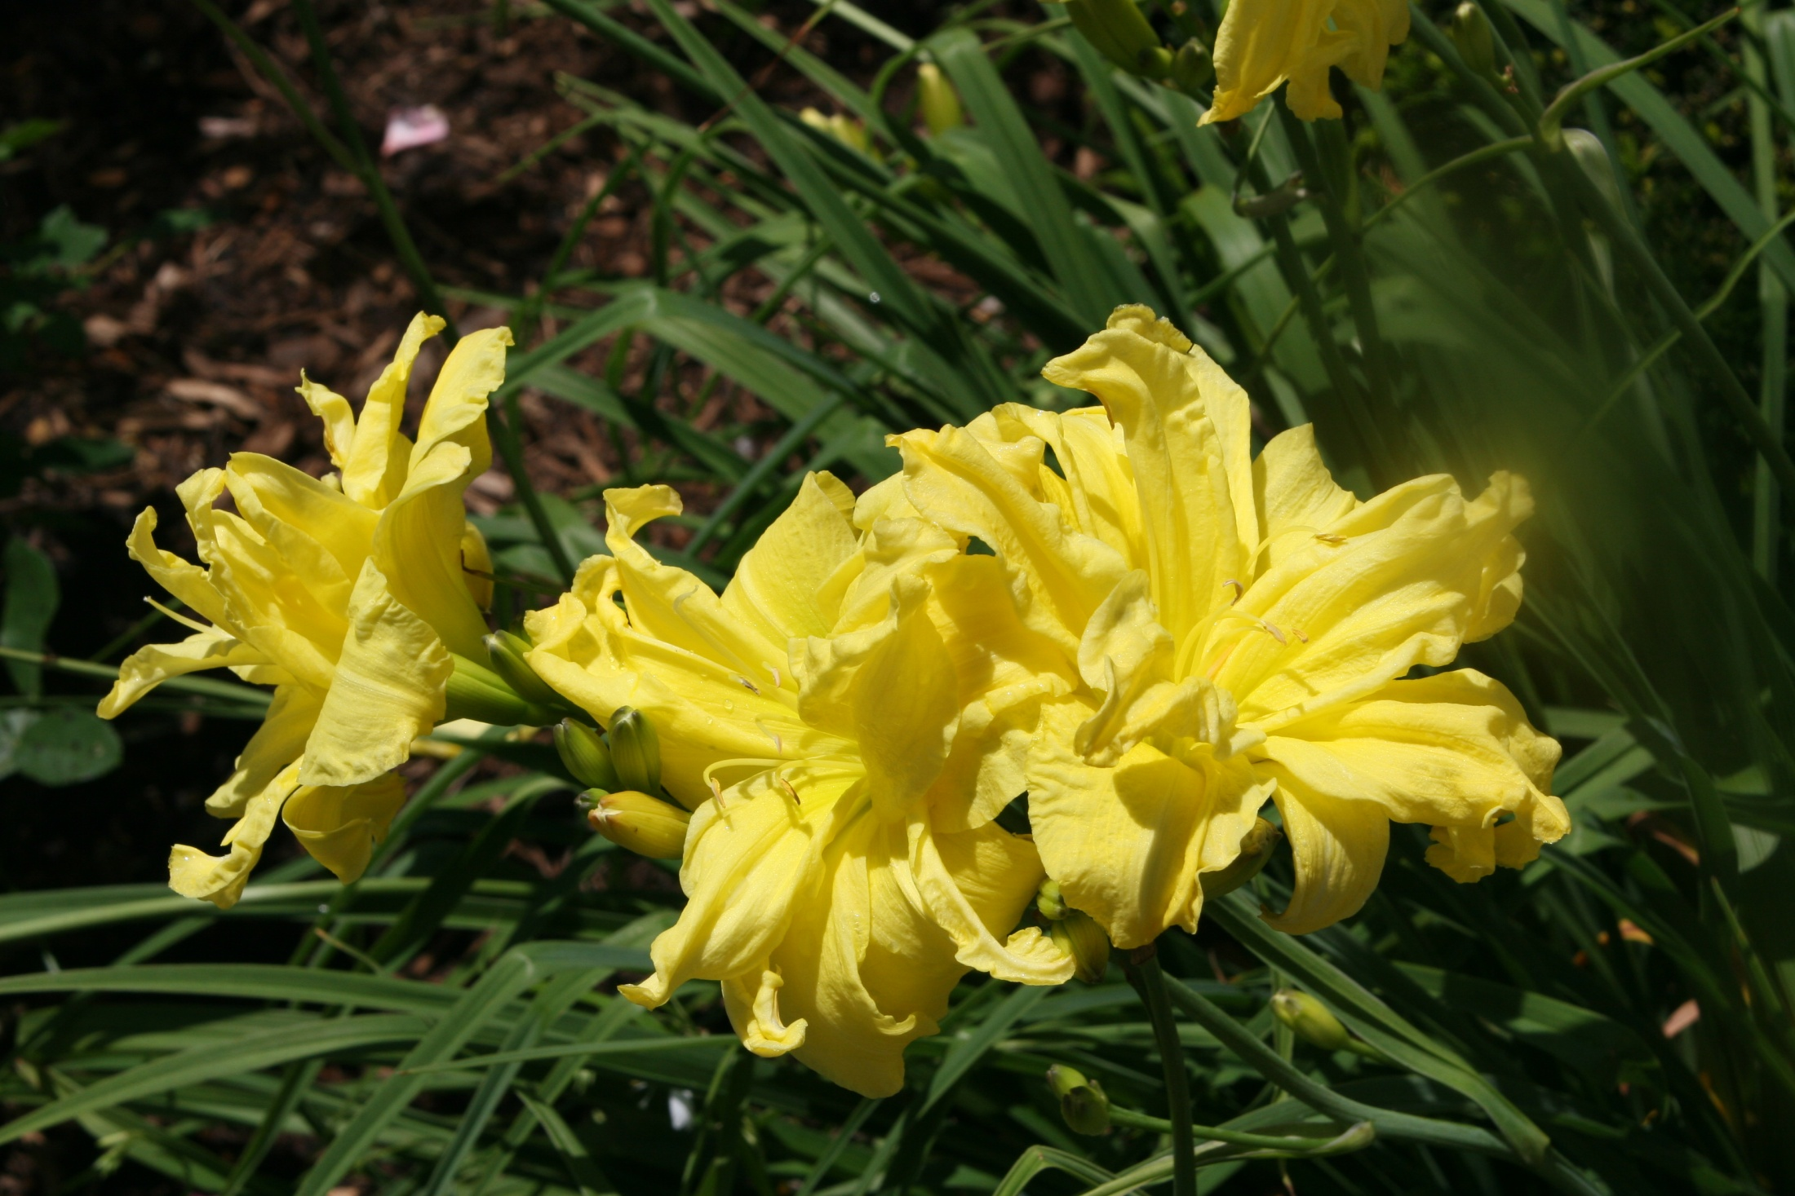 |  |  | Double River Wye  30" tall  4.5" double yellow flowers midseason  Fragrant  Heavy bloomer |  | 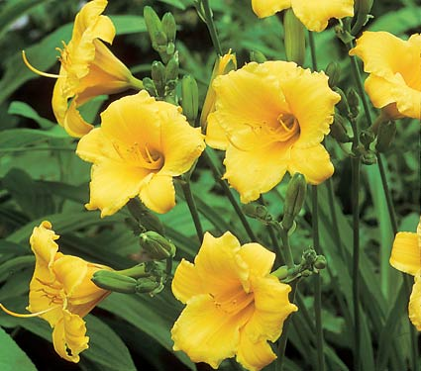 | Fragrant returns  18”tall, 3” lemon yellow flowers  Very hardy; multiplies well
 | 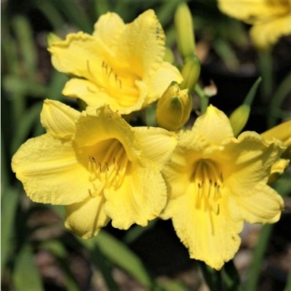 |  |  | Happy Returns  12-18”’ tall, 3” canary yellow flowers  Reblooms from May – frost  Fragrant  Very hardy; multiplies well |  | 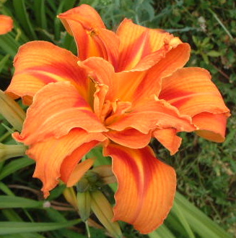 | Kwanso  4-5’ tall  4” orange double’or triple flowers in July-August  Related to “ditch lilies” but not as invasive.
 | 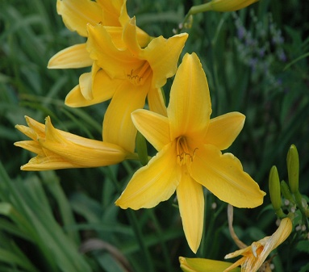 |  |  | Lemon Lily  Species dayily  18-24”tall, 3”light yellow, funnel-shaped flowers.  Fragrant  Early summer, sometimes reblooms | 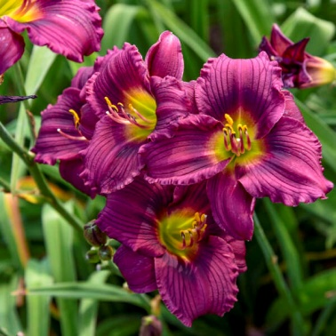 |  | Little Grapette  18”tall,  3”beautiful purple flowers  Blooms in mid-summer
 | 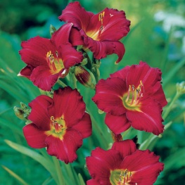 |  |  | Pardon Me  14-18”tall  Dark red 2”blooms  Prolific bloomer | 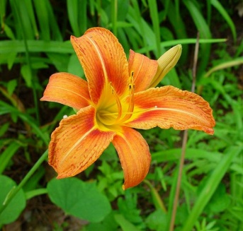 |  | Tawny Daylily  Hem. Fulva  Called “Ditch Lily” it may become invasive. Plant in a contained bed.  3-4’tall, 4” flowers  Blooms May - July
 | 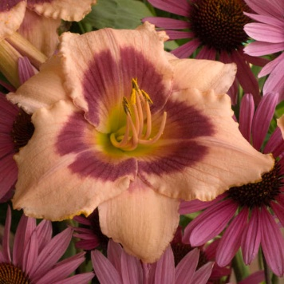 |  |  | 2’tall, 5” flowers  Peach w. wine ring  Fragrant  Long-blooming
Hostas
All grow beautifully in part-full shade. Some can also take sun, as long as it isn’t direct, full sun.

 | 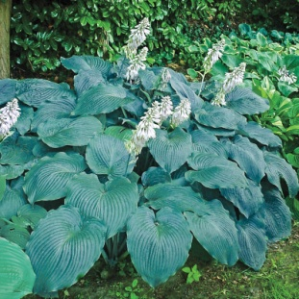 |  |  | Blue Angel $10  30 x 36”  Part-full shade  Fragrant flowers in mid-summer attract hummingbirds |  | 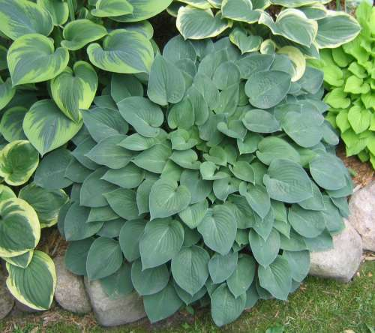 |  | Blue Cadet $10  15 x 25”  Soft blue leaves turn green in mid-summer  Lavender flowers in July
 | 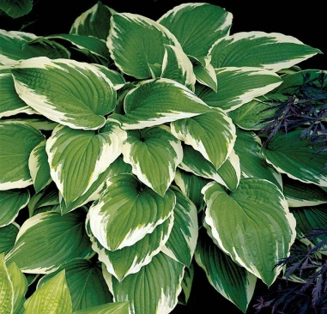 |  |  | undulate albomarginata  --The Classic!  15X25”  Lavender flowers  Will multiply over time  Part Sun - Full Shade |  |  |  | Emerald Tiara
 | 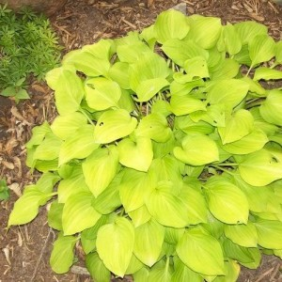 |  |  | Hosta Gold Edger  8 x 10”  Sun – shade  Multiplies quickly  Lavender flowers in July  $10 |  | 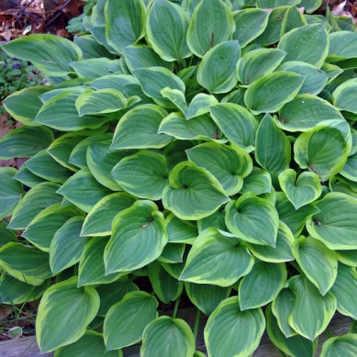 |  | Hosta Golden Tiara  16” x 20”  Forms colonies over time.  Showy purple flowers in July  Attracts hummingbirds
 | 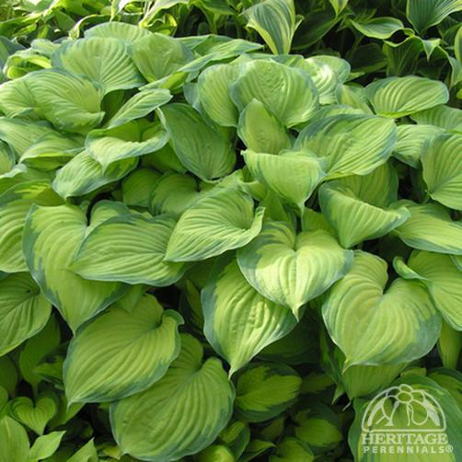 |  |  | Guacamole 10  22 x 30”  Fragrant lavender flower mid-summer |  | 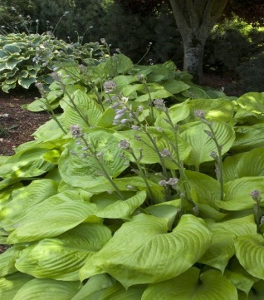 |  | Sum & Substance  Shade  GIANT:  40"tall x 48"wide  Light green foliage
 | 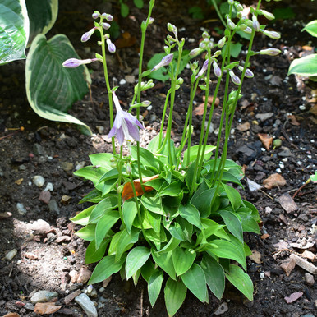 |  |  | Venusta Ogon Otome  3-4" tall, 6-8” wide Will spread to form new plants.  Golden-yellow foliage, lavender flowers in summer  .  Rare! $10.
 | Native Perennials for Sun
 | 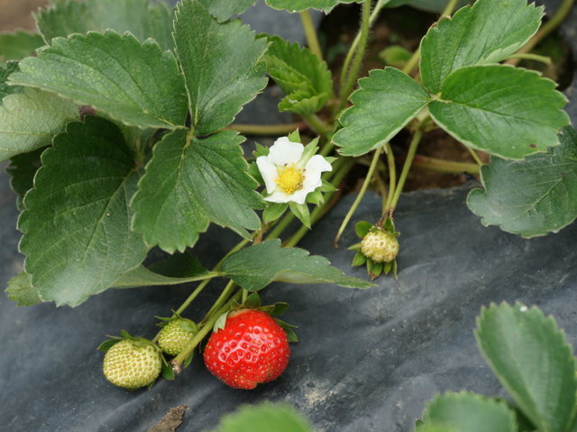 |  |  | Fragaria: Strawberries  6-10" tall  Flowers May – June; fruit in June.  Super Sweet!  Full Sun - Part Shade |  | 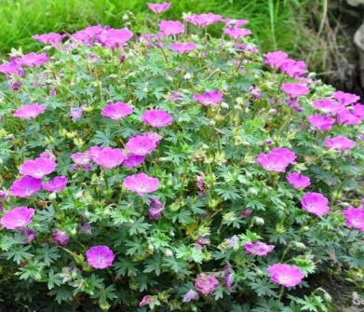 |  | Cranesbill aka Wild Geranium  Geranium maculatum  Also grows in part shade.  Blooms off and on all summer.
 | 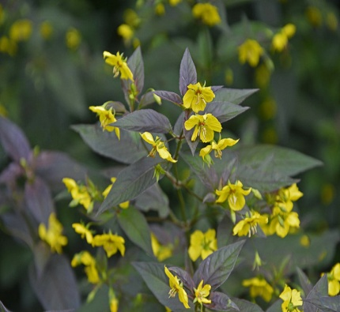 |  |  | Lysimachea Ciliata “Fireworks”  2’ tall  Full sun or light shade  Yellow flowers all summer  Foliage is dark purple in spring; fades to green in late summer. |  | 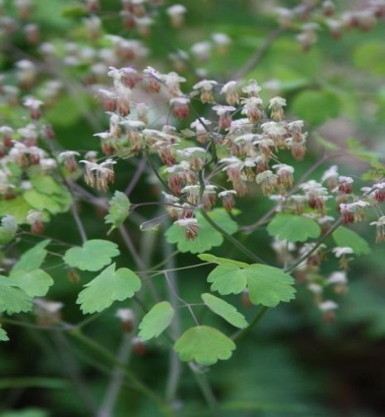 |  | Meadow Rue  Thalictrum dioicum  2 x 2’  Full sun or dappled shade  Moist soil  Tiny white flowers in spring
 | 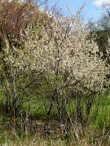 |  |  | Wild Plum Tree  Prunus Americana  15' over many years  Pretty, fragrant flowers in spring  Birds love the fruit  Thorns |  | 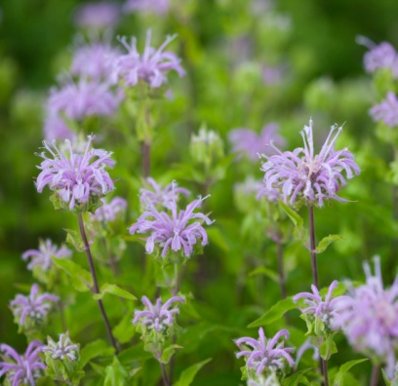 |  | Bee Balm, Wild Bergomat  Monarda  3-4’tall  Frilly pink-purple flowers bloom July – September  Medicinal uses
 | Non-Native Perennials for Sun
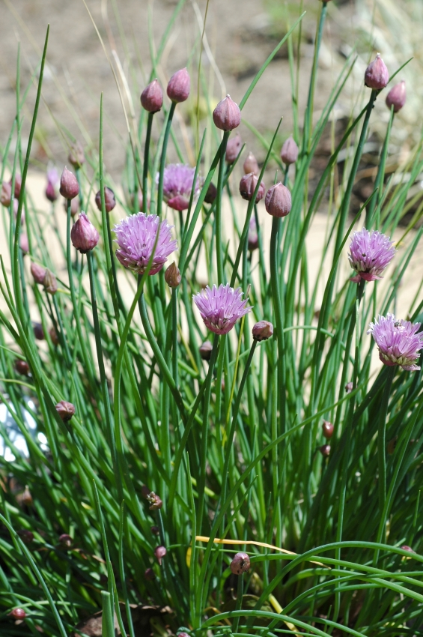 |  |  | Chives  Allium  1’ tall  Cooking herb.  Use the flowers in salads. |  | 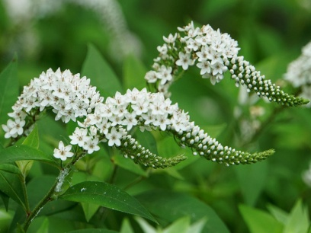 |  |  |  | Gooseneck Loosestrife  Lysimachea clethroides  1-2’ tall  Full or partial sun  NOT the invasive loosestrife, but very vigorous. Spreads by rhizomes.
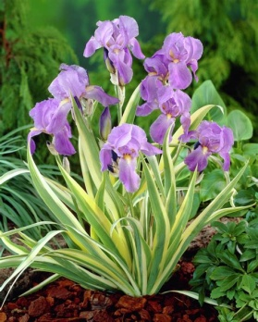 |  | Iris Pallida Gold  12-18”  Grape-like fragrance  Blooms in late spring |  |  | 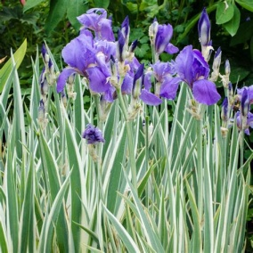 |  |  |  | Iris Pallida Silver  12-18”  Grape-like fragrance  Blooms in late spring
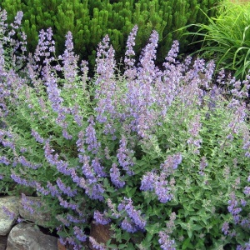 |  |  | Walker’s Low Catmint  Nepeta  2’ tall x 3’ wide-looks like a shrub  Purple blooms last 5 months  Fragrant  Attracts butterflies & hummingbirds
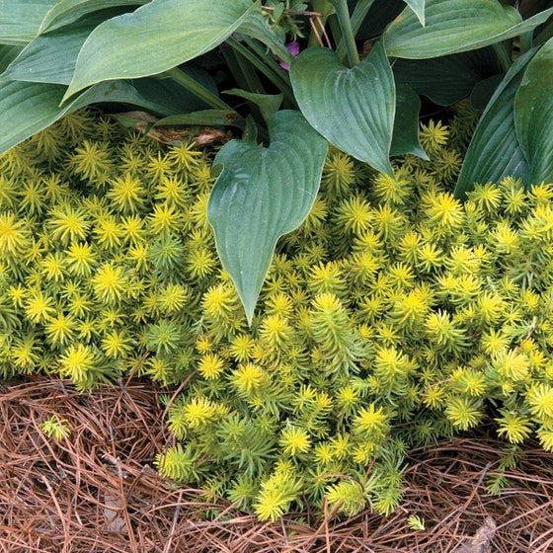 |  |  | Sedum Angelina  2-3” groundcover  Evergreen  Great for rock gardens |  | 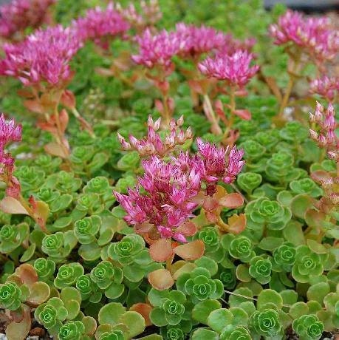 |  |  |  | Sedum John Creech  2-3” groundcover  Evergreen  Great for rock gardens
 | Native Perennials for Shade
 | 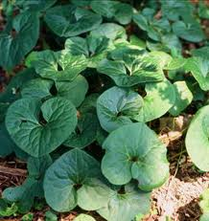 |  |  | Wild (or Canada) Ginger  Asarum  1’  Great ground cover  Tiny flowers in spring |  | 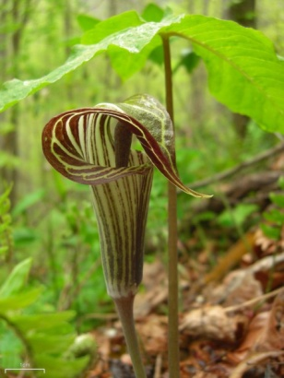 |  | Jack in the Pulpit  Arisaema  1’ tall  Part – full shade  Cup-like flower in spring followed by bright red berries.
 | 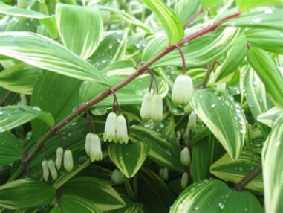 |  |  | Solomon’s Seal  2' tall  Long-blooming late spring-early summer  Small red berries in fall |  | 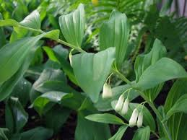 |  | False Solomon’s Seal  1-2 feet tall  Fragrant white flowers in June or July  Extremely hardy
 | 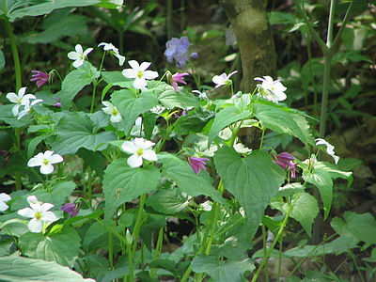 |  |  | Canada Violet  Viola Canadensis  8-10” tall  Part – Full Shade  Spreads slowly by rhizomes to form a colony.  White flowers in spring & fall |  | 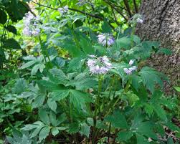 |  | Virginia Waterleaf  Hydrophyllum  Full Shade - Part Shade  6 - 12" tall  Pale lavender flowers  Spreads to form mats; good groundcover
 | 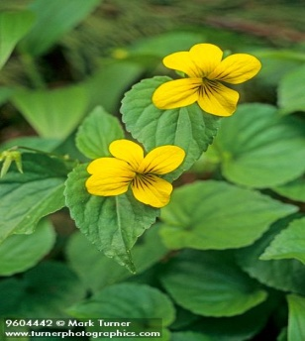 |  |  | Downy Yellow Wood Violet $10  Viola pubescens  4-12”  Small, yellow flowers  Blooms May – June
 | Non-Native Perennials for Shade
 | 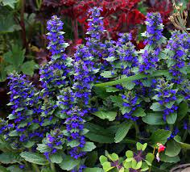f |  |  | Ajuga  Carpet Bugle  3-4” mats of multi-colored leaves w 5” spikes of blue-purple flowers in spring.  Will also grow in sun, but doesn’t reach full size. |  | 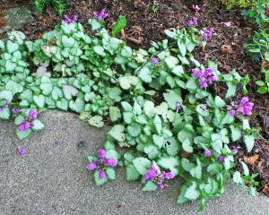 |  | Pink Nancy and Red Nancy  Lamium  6 x 10”  Groundcover-spreads quickly  Grows in sun, part shade, full shade  Reblooms all summer

